Step 1: Total articles: 1889
PubMed:
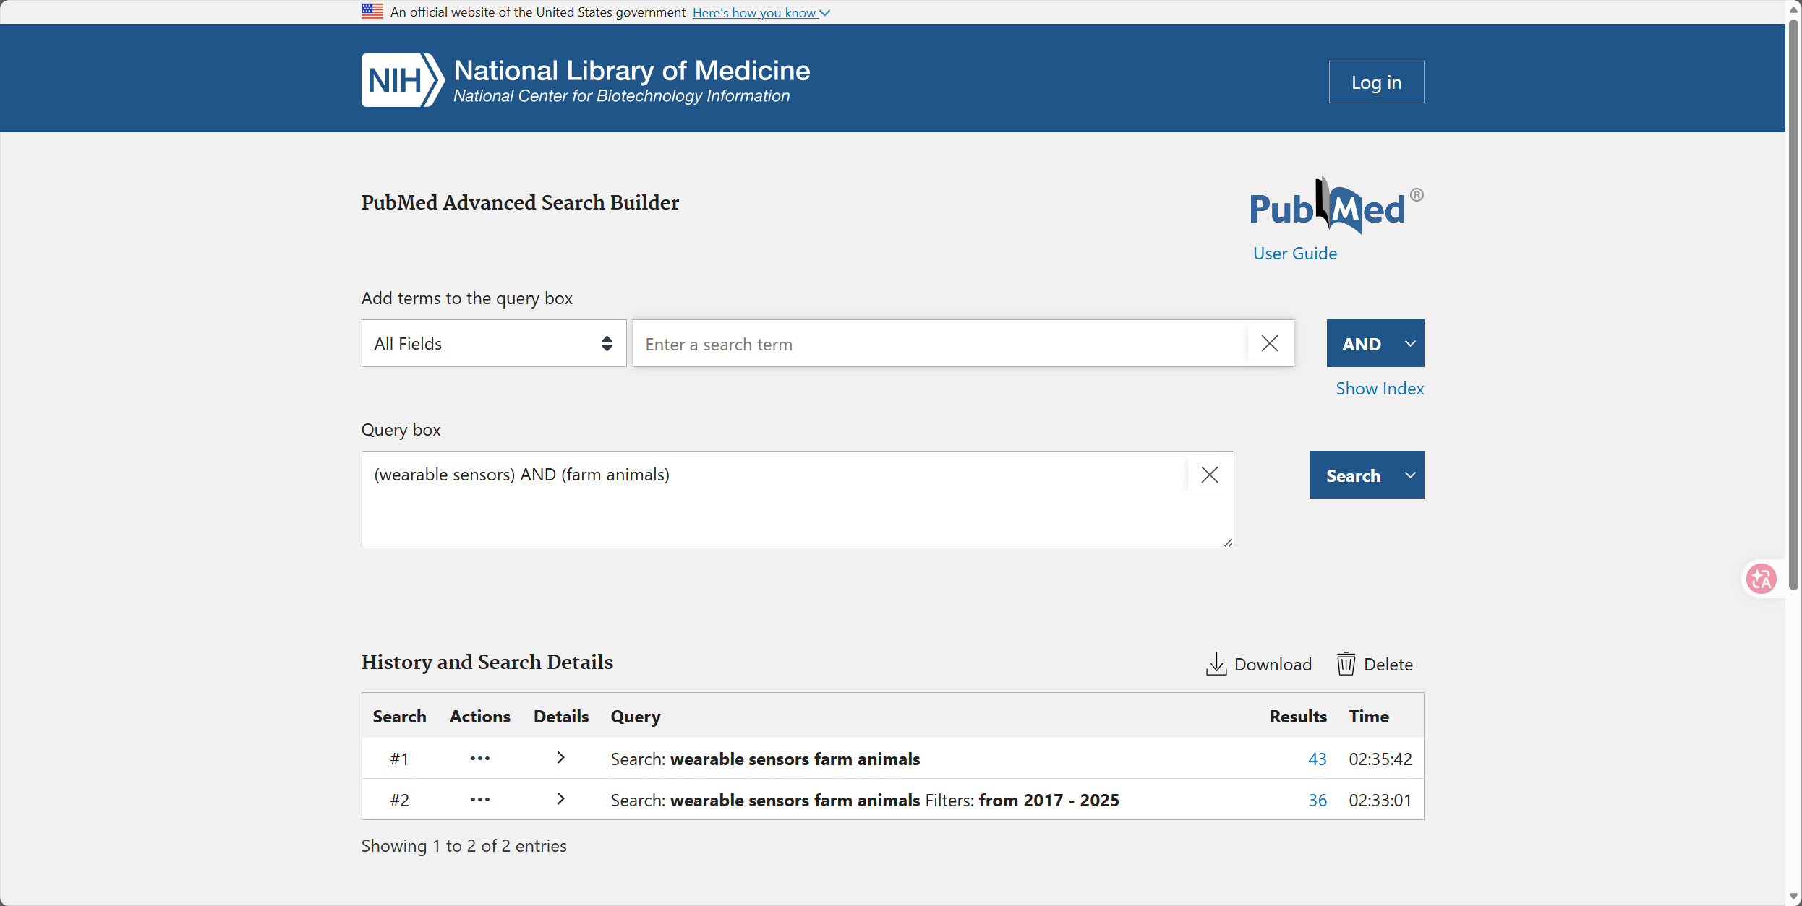
Web of science:
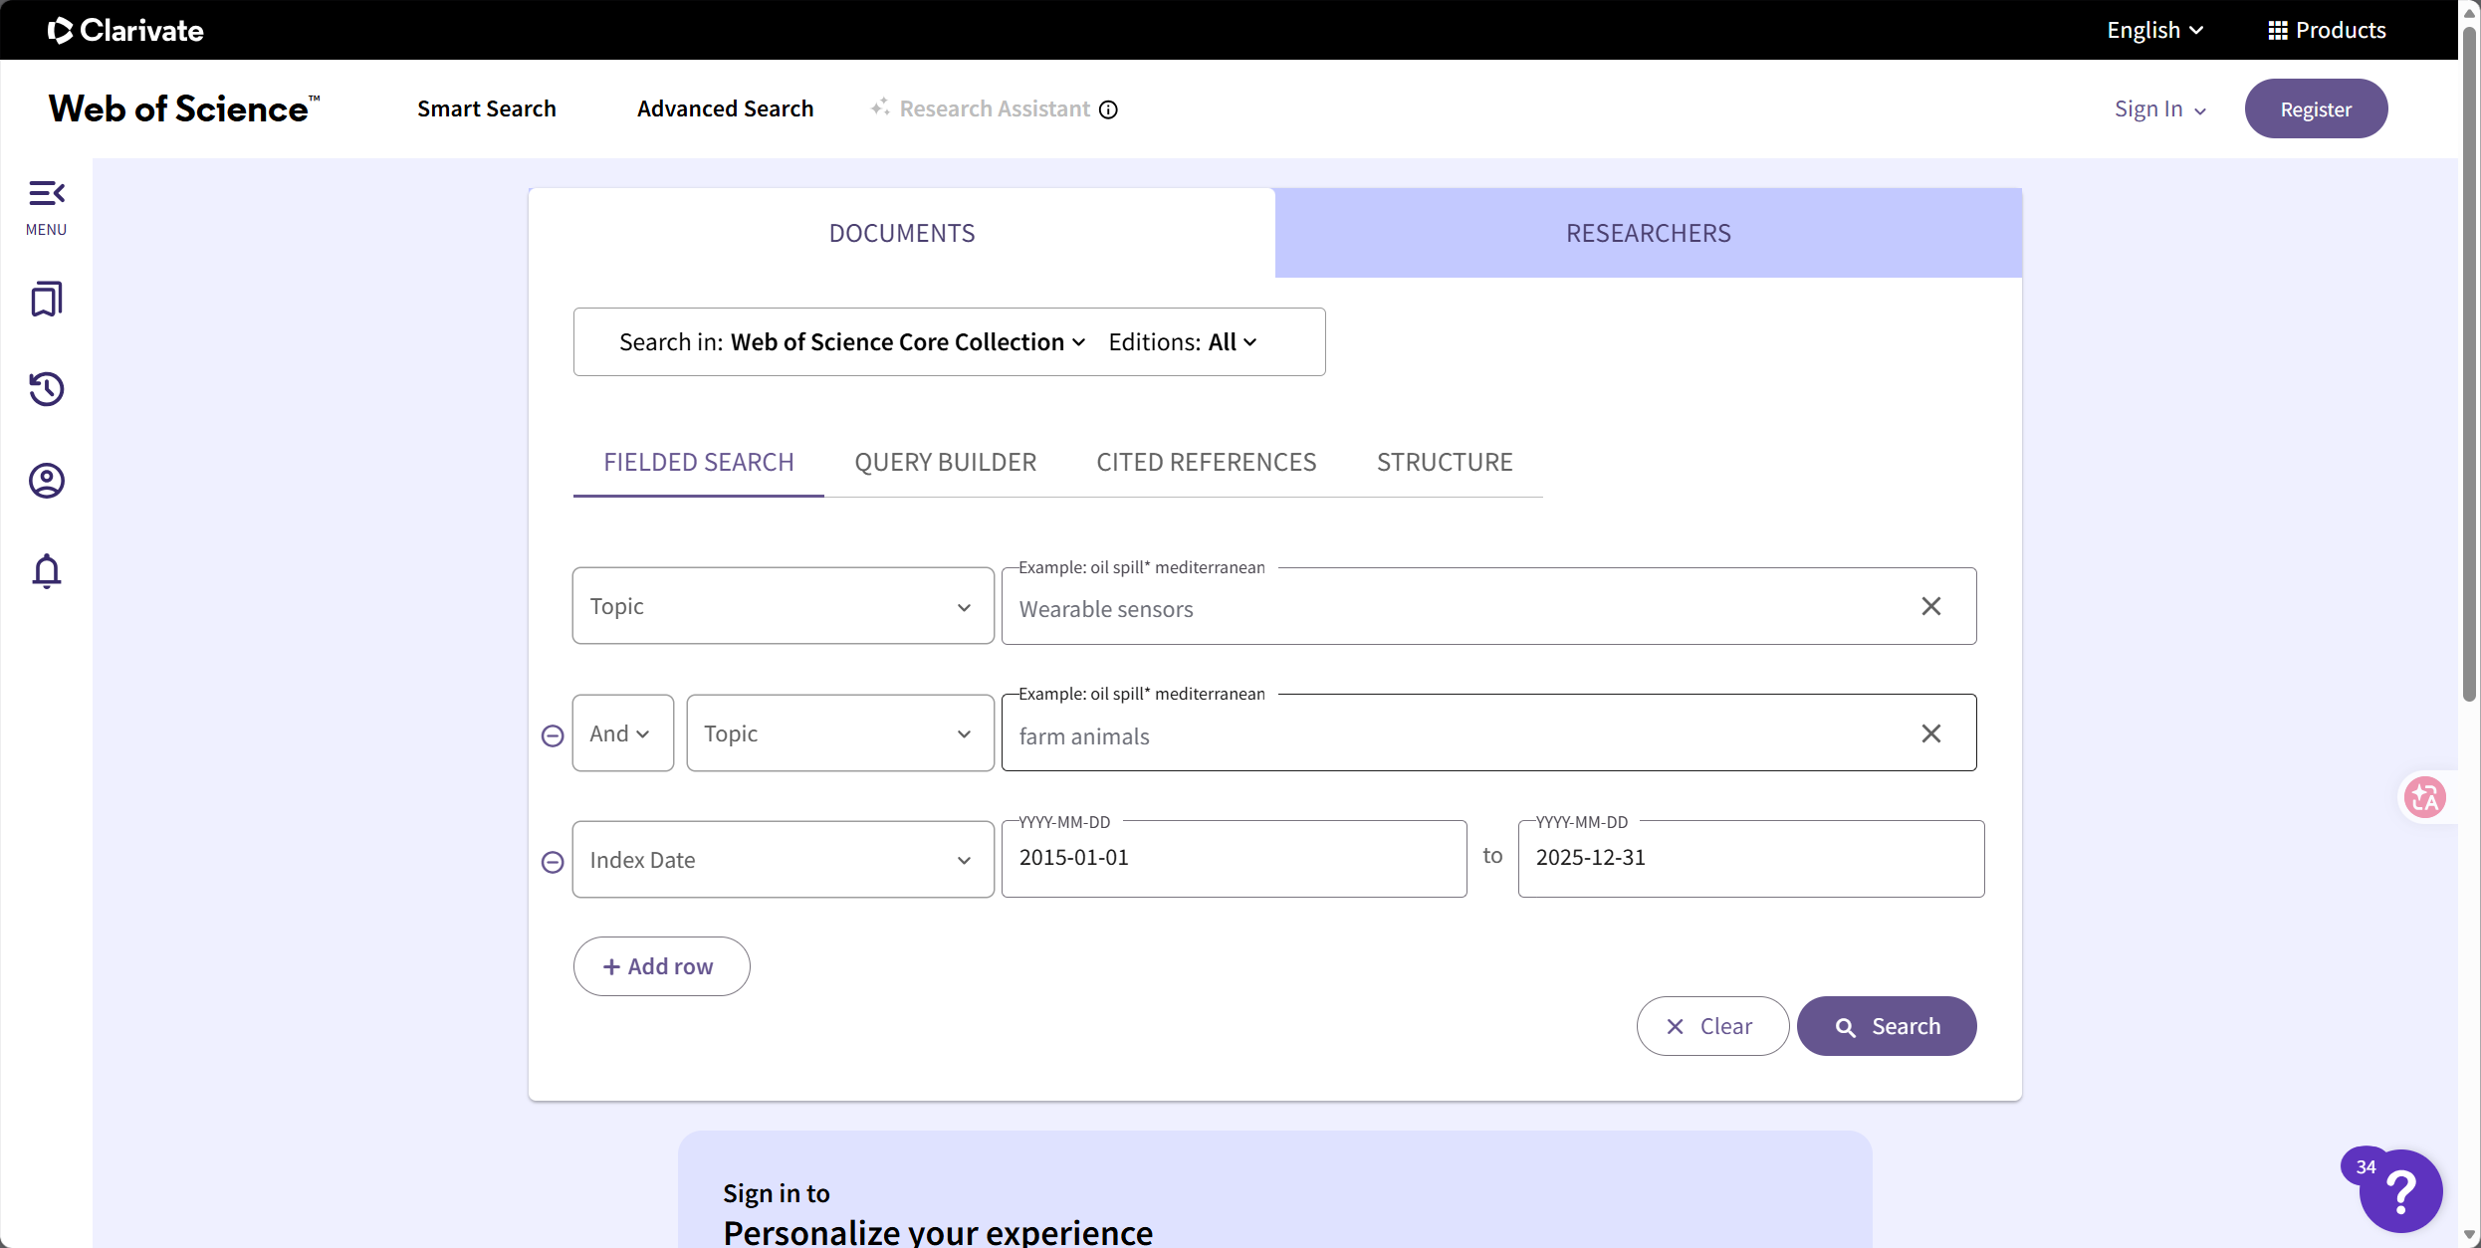
ScienceDirect:
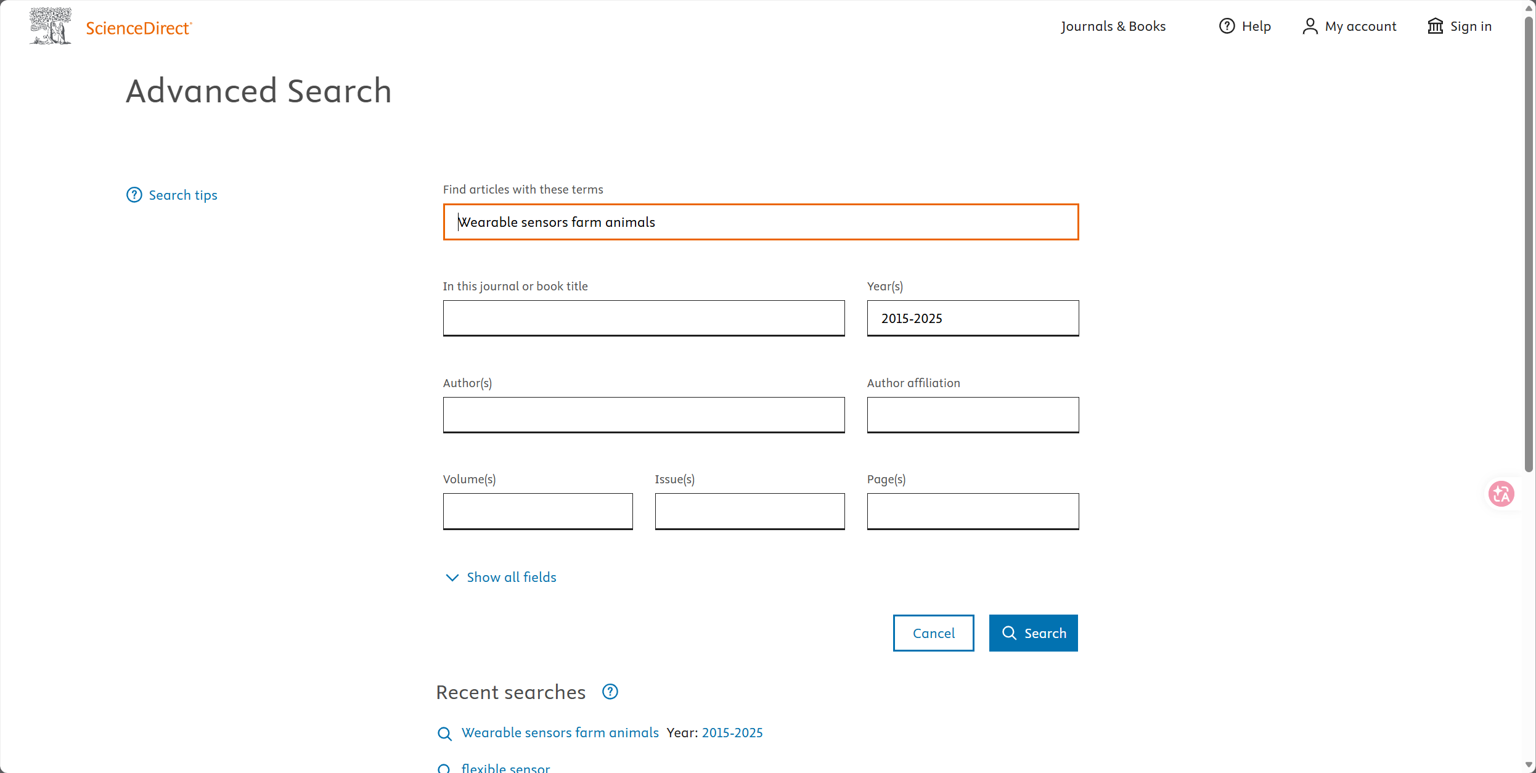
IEEE Xplore:
